
Product Features
- Digital display, one-click pairing, automatic connection, no setup required—simple and quick to use without a phone or computer.
- Supports peer-to-peer and point-to-multipoint bridging, offering flexible applications to meet diverse use cases.
- 5.8 GHz frequency band, supporting spread spectrum technology with a maximum wireless transmission rate of 867 Mbps;
- Exhibits strong anti-interference capability, remains unaffected by external environmental factors, and ensures stable transmission;
- Equipped with MediaTek's engineering-grade chips, delivering stable and reliable performance.
- Featuring a high-power circuit design with an integrated high-gain directional antenna, it delivers strong signal strength and extended transmission range.
- Two 10/100/1000 Mbps adaptive Ethernet ports (both support 24V PoE power supply);
- Supports automatic restart, reduces system operation cache, optimizes system performance, and ensures smooth long-term device operation.
- Supports hiding the bridging SSID from wireless signals to prevent wireless devices from detecting it, protect network data from malicious attacks, and ensure user data security.
- Supports both 24V PoE and 12V DC power supplies with plug-and-play functionality for flexible power sourcing.
- Featuring an outdoor rain-resistant design with IP65 protection rating, it is resistant to rain, dust, wind, and sunlight, effortlessly adapting to various harsh outdoor conditions while ensuring long-term stable operation.
- With a square design that is simple yet elegant, it's easy to install—available for wall mounting or bracket fixation.
- Suitable for various outdoor application scenarios, including construction site monitoring, tower crane monitoring, scenic area monitoring, elevator monitoring, factory premises monitoring, port monitoring, residential community monitoring, and outdoor network transmission.
size of product
product name | 900M high-power dual-port gigabit digital wireless bridge
product model | WB5891F
Hardware Specifications
hardware system | Main Chip | MT7621AT+MT7612EN
hardware system | internal storage | 128MB
hardware system | FLASH | 8MB
hardware system | PA | high-power PA
Wireless Parameters | protocol standard | Supports IEEE 802.11ac and is backward compatible with IEEE 802.11a/an
Wireless Parameters | Working Frequency Band | 5.8GHz：5180MHz ~5825MHz
Wireless Parameters | Wireless Speed | 867Mbps
Wireless Parameters | transmitting power | 23dBm
Wireless Parameters | receiving sensitivity | -92dBm
physical interface | network interface | Two 10/100/1000 Mbps Ethernet ports (both support 24V PoE power supply)
physical interface | Hardware Button | 1 digital button/RESET button
physical interface | Power Supply Interface | One DC power port, supporting 12V DC power supply
physical interface | Pull the switch | 1 pull-down switch (free switching between terminals A and B)
physical interface | Digital Display | 1 digital display (supporting 16 channels from 0 to 9, A to F)
Wireless Type | Wireless Type | Built-in 14 dBi, 5.8 GHz bipolar directional antenna
pilot lamp | LED pilot lamp | PWR，LAN1，LAN2，4*LINK，WLAN
Power Supply/Power Consumption | power supply mode | Supports DC 12V/1A power supply, 24V PoE power supply, and 48V PoE power supply
Power Supply/Power Consumption | Total Power of the Device | ﹤8W
Product Accessories | main engine | 900M High-power Dual-Port Gigabit Digital Wireless Bridge Host *1
Product Accessories | Power Adapter | 24V/1A Gigabit PoE Power Supply
Product Accessories | else | Stainless steel clamp *1  User Manual *1  Qualification Certificate *1
Appearance/Packaging/Weight | Appearance Color | white
Appearance/Packaging/Weight | product size | 250mm*90mm*54m
Appearance/Packaging/Weight | packing measurement | 272 mm × 235 mm × 73 mm (set of two)
Appearance/Packaging/Weight | weight | 2.4 kg (per pack)
Appearance/Packaging/Weight | carton size | 570*386*492mm
Appearance/Packaging/Weight | packing quantity | 40 pieces per box
Appearance/Packaging/Weight | net weight | 48kg
Appearance/Packaging/Weight | rough weight | 49.5kg
else | The optimal power supply distance for a PoE network cable | Within 65 meters (using Category 5e or higher network cables)
else | Bridge Distance | 0–5 km
else | IPC Load Capacity | Route 20: No lag, no delay
else | way to install | Rod mounting, Wall-mounted installation, Support bracket installation
else | levels of protection | IP65 rating; 2 kV lightning protection
Software Specifications
Bridge Networking Method | Digital Pairing | Supports digital display and one-click pairing – convenient, simple, and fast
Bridge Networking Method | Manual Pairing | Support (available when digital display function is turned off)
Bridge Networking Method | Point-to-point bridging | support
Bridge Networking Method | Point-to-multipoint bridging | support
network | work pattern | AP Mode, WDS Bridge Mode, WDS Repeater Mode, AP-Client Mode, AP-Client+AP Mode
network | LAN Configuration | support
network | WAN/LAN Flow Rate Control | support
network | DHCP server | support
network | Network Traffic Monitoring | support
Wireless Settings | Wireless Switch | support
Wireless Settings | Enable wireless timing | support
Wireless Settings | SSID set up | support
Wireless Settings | SSID hide | support
Wireless Settings | Wireless Security | Supports multiple encryption methods
Wireless Settings | Wireless Mode Settings | support
Wireless Settings | Bandwidth Settings | support
Wireless Settings | Wireless Channel Settings | Supports spread spectrum
Wireless Settings | Wireless User Isolation | support
Wireless Settings | Wireless Power Regulation | support
Wireless Settings | Visitors Network Settings | support
Wireless Settings | access control | support
system management | Web interface management | support
system management | user management | support
system management | firmware upgrade | support

interface specification
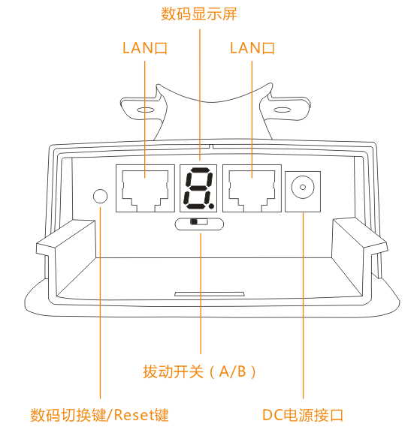
product size
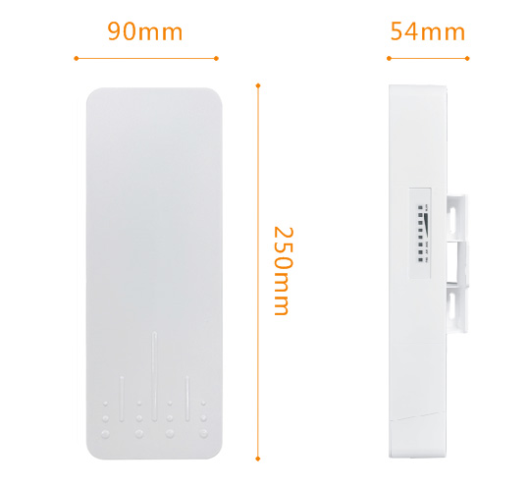
Product Application
I. Point-to-point wireless monitoring transmission applications 1

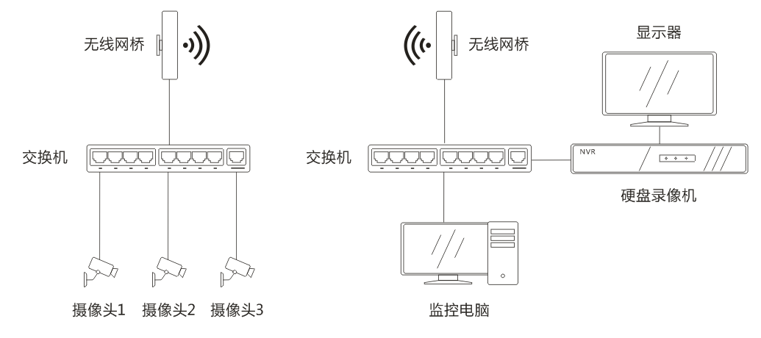

II. Point-to-point wireless monitoring transmission applications 2

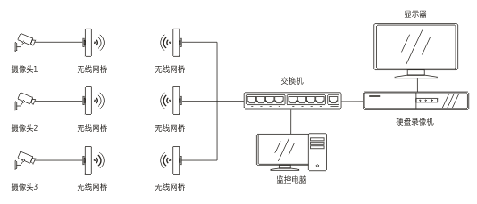

III. Wireless Monitoring Transmission: Point-to-Multipoint Applications 3

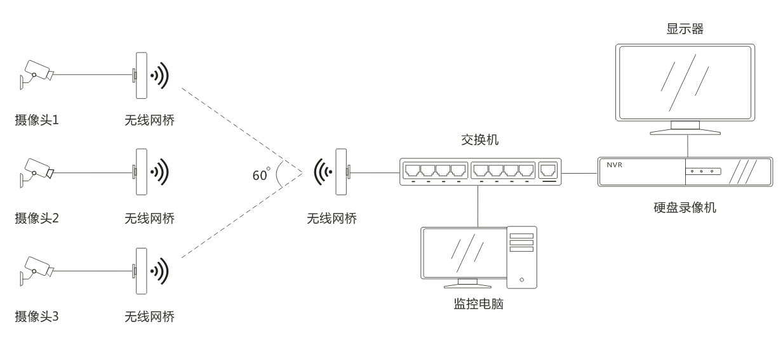

IV. Internet of Things Data Transmission Applications

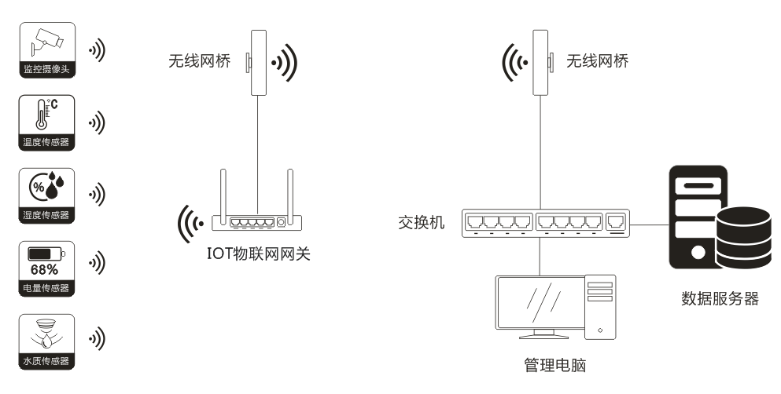

V. Applications of Wireless Data Transmission over the Internet 1

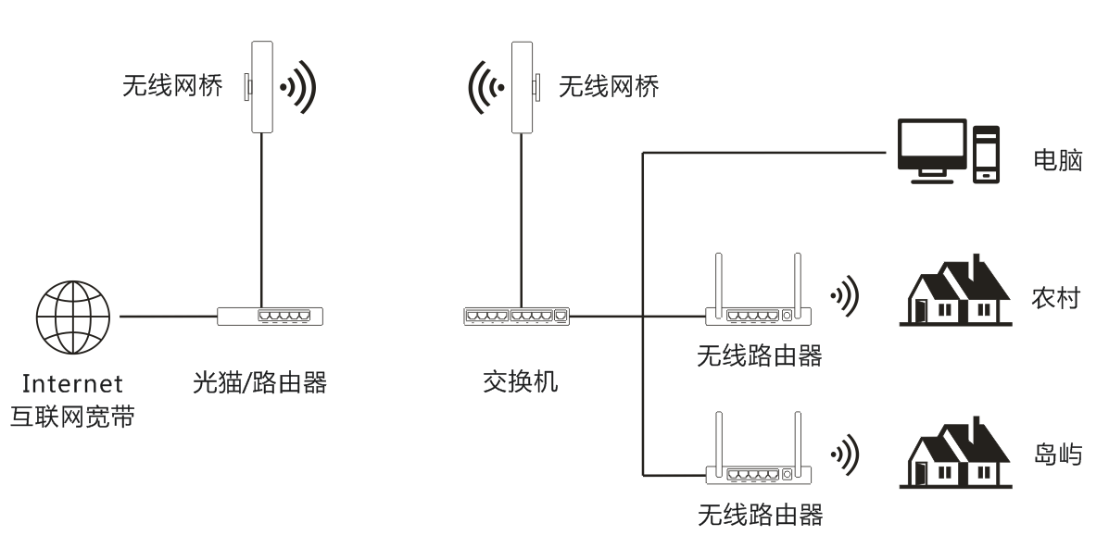

VI. Internet Wireless Transmission Applications 2
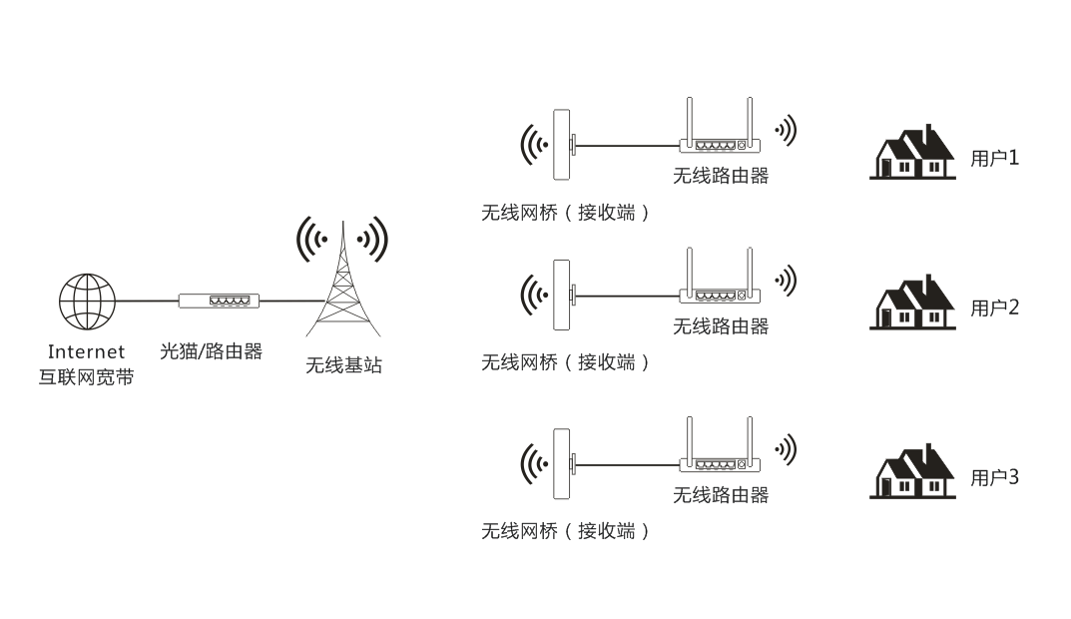

VII. Internet Coverage Applications 3

